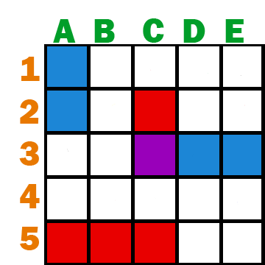
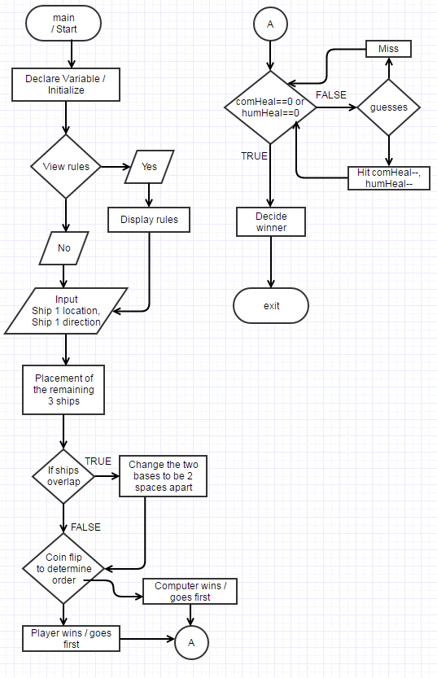
Project 1
<War Chess>

CIS17A-44051
Name: Cody Steimle
Date: 04/07/17
Introduction:
Title: War Chess

Taking the idea of how a standard Chess game works, I decided to do my project based around that concept but with a twist. Instead of the King being the most important piece with 17 other pieces each having their own movement traits, I have a total of 6 pieces for each player with 3 different classes. Each player, the user and an A.I, will have a total of: 3 Infantry units, 2 Commanders, and 1 General. The General is what acts as the King piece of the game, once that piece is lost the opposing player will win the game.

Each piece’s traits are stored within a structure called “Army.h”, and these traits are: the health remaining, attack power, movement length, and its location relative to the board.
Infantry can move up to three spaces at a time, but only have 1 attack power and 1 health point. Commanders are the balanced units with health, attack, and movement all being 2. Generals have 3 health points, but attack and movement are only 1, so they will need to be protected.

These pieces are setup for each of the players to maintain a balanced game. A turn consists of 1 attack and 1 movement action before ending.

For each turn, the player has the option to: 1) check a unit’s status by printing out data from its structure, 2) select a unit to move and where to, 3) attack an adjacent unit, and 4) the option to end their turn early if so desired. However, movement and attacking has limitations. When moving the player is forced to stay within bounds of the map and will not be allowed to land on top of other unit. Also for both movement and attacking, diagonals are not accepted.

The computer has separate functions for turn, attacking, and moving so the inputs are randomized.

The player will enter their name which will be used throughout the game and also printed to the results file.

There are 2 health packs randomly placed within the map, and if a unit were to land on it, then that exact unit will gain +2 to their remaining health (this means a General could have a total of 7 health if it were to collect both!).

Before the game begins a coin toss is done to find out who will be taking the first turn. After that is decided the game will alternate between players as they take their turns. The turns are kept track of will be written to the results file post-game.

Once the game is over the player will be shown the winner and will also be asked if they would like to print the results to a file.
Visual Example: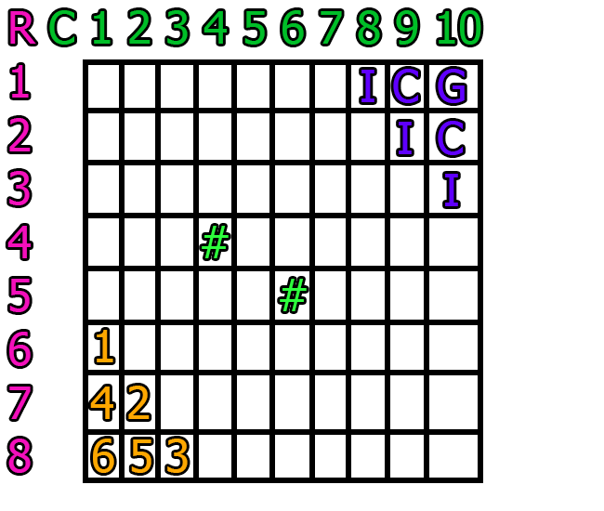
*Purple = Computer's pieces
*Orange = Player's pieces
*Green = Health power-ups

Development Summary:

Project size: over 1100 Lines
Number of variables: about 70
Number of functions: about 25
Number of structures: 1

Thanks to structures I was able to shrink down an already monstrous sized code significantly. Being able to pass in the structure and have it contain all the variables I need made writing this game fairly simple, but it still took days of work to complete. Since I've done a Battleship like game in CSC5 I knew how the 2D array board and ranges worked and was able to apply similar concepts here. One major difference here though I the pieces will move and not just remain static, and coding this is where most of my time was spent. I was also able to get the Computer to move by selecting a random unit and moving in a random direction with the compMov function. If the computer is unable to perform that move then it would re-run the function until it find a viable action. The same idea was used for attacking. Throughout the code I used many flags to prevent the duplication of moving and attack. The board is emptied and re-written to each time it is showed, and when a unit dies it's space will be emptied.

Use multiple paragraphs if needed.

Chapter Concepts:

Textbook | Chap.Sec | Concept | Code Location
Gaddis 8th | 2.2 | cout | Line
Gaddis 8th | 2.3 | #include
Gaddis 8th | 2.4 | Variables
Gaddis 8th | 2.5 | Indentifiers
Gaddis 8th | 2.6 | Integers
Gaddis 8th | 2.7 | Char
Gaddis 8th | 2.8 | strings
Gaddis 8th | 2,10 | bools
Gaddis 8th | 2,11
Gaddis 8th | 2,12
Gaddis 8th | 2,13
Gaddis 8th | 2,14
Gaddis 8th | 2,15
Gaddis 8th | 2,16
Gaddis 8th | 3.1
Gaddis 8th | 3.2
Gaddis 8th | 3.3
Gaddis 8th | 3.5
Gaddis 8th | 3.6
Gaddis 8th | 4.1
Gaddis 8th | 4.2
Gaddis 8th | 4.4
Gaddis 8th | 4.5
Gaddis 8th | 4.6
Gaddis 8th | 4.7
Gaddis 8th | 4.8
Gaddis 8th | 4.9
Gaddis 8th | 4,10
Gaddis 8th | 4,11
Gaddis 8th | 4,14
Gaddis 8th | 5.1
Gaddis 8th | 5.2
Gaddis 8th | 5.4
Gaddis 8th | 5.5
Gaddis 8th | 5.6
Gaddis 8th | 5,10
Gaddis 8th | 5,11
Gaddis 8th | 6.2
Gaddis 8th | 6.3
Gaddis 8th | 6.4
Gaddis 8th | 6.5
Gaddis 8th | 6.6
Gaddis 8th | 6.7
Gaddis 8th | 6.8
Gaddis 8th | 6.9
Gaddis 8th | 6,10
Gaddis 8th | 6,13
Gaddis 8th | 7.1
Gaddis 8th | 7.2
Gaddis 8th | 7.4
Gaddis 8th | 7.5
Gaddis 8th | 7.6
Gaddis 8th | 7.8
Gaddis 8th | 7.9
Gaddis 8th | 7,10
Gaddis 8th | 8.1
Gaddis 8th | 9.1
Gaddis 8th | 9.2
Gaddis 8th | 9.5
Gaddis 8th | 9.7
Gaddis 8th | 9.8
Gaddis 8th | 11.1
Gaddis 8th | 11.2
Gaddis 8th | 11.3
Gaddis 8th | 11.4
Gaddis 8th | 11.5
Gaddis 8th | 11.7
Gaddis 8th | 11.9
Gaddis 8th | 12.1
Gaddis 8th | 12.3
Gaddis 8th | 12.4
Gaddis 8th | 12.6
Gaddis 8th | 12.7
Gaddis 8th | 12,10

Flowcharts:

*Place pictures here
Pseudo Code:
Initialize
Set the random seed
Show menu with play and view rules option
User inputs 1 or 2
Get the player's name and store to a string
Fill the game board with health power-up
Create the teams for each player from a structure
Player names their individual units
The unit are given locations and printed to the board
Start game
Coin flip to determine order
Winner goes first and alternates players
Players will attack and move
Loop until a General health becomes zero or lower
Game ends
Winner is decided through a flag
Prompt the user to save results to file
Exit Program.

Variables:
Data Type | Name | Location | Description
const int | ROWS=8 | global | Number of rows for game board
const int | COLS=10 | global | Number of columns for game board
string | name | main | Player's Name
bool | isWinnr | main | Flag for the winner (0 = lost, 1 = won )
char | board[ROWS][COLS] | main | The board (2D array)
int | turn=1 | main | Counter for turns
Army | unit[12] | main | Structure array of the units
int | menuItm | ttlScrn | Choice for menu
ifstream | in | ttlScrn | Input file for title screen
int | NumHP=2 | fillMap | Number of health packs
int | randRow | fillMap | Random row (for health packs)
int | randCol | fillMap | Random col (for health packs)
int | rowNum=1 | shwMap | Counter display for rows
int | colNum=1 | shwMap | Counter display for cols
string | filLine | prntfil | A line of the file
string | filLine | binPrnt | A line of the file
char | mapIcn='1' | mkeArmy | Used for setting the icons for the player
string | line | nmeArmy | Stores a line of text input
char | human | coinFlp | Human input
int | coin | coinFlp | Coin flip for heads or tails
bool | isWon | coinFlp | Did the player win coin flip
bool | isOver=0 | strtGam | Checks if the game is over
bool | isWinnr=0 | strtGam | Checks if the player won
bool | isMoved=0 | pTurn | Flag for if move option has been used
bool | isAtked=0 | pTurn | Flag for if attack option has been used
bool | isOver=0 | pTurn | Checks if the game is over
char | input | pTurn | Human input
bool | isMoved=0 | cTurn | Flag for if move option has been used
bool | isAtked=0 | cTurn | Flag for if attack option has been used
bool | isOver=0 | cTurn | Checks if the game is over
char | input | cTurn | Computer input
bool | isAtked=1 | plyrAtk | Flag for if attack option has been used
char | directn | plyrAtk | Direction
int | pikArmy | plyrAtk | Choice of unit
int | unitR | plyrAtk | Stores unit's Row
int | unitC | plyrAtk | Stores unit's Column
int | target | plyrAtk | The unit number of the defender
int | targetR | plyrAtk | Targets Row
int | targetC | plyrAtk | Targets Column

Functions:
Type Name | Purpose | Inputs | Outputs
void ttlScrn | Main menu | menuItm, in | compCol, compRow
void prntfil | Prints an entire file | file | file
void binPrnt | Prints an entire file (binary) | file | file
void getName | Get the player's name
void disRule | Display rules
bool coinFlp | Coin flip
void fillMap | Fill in the game board
void plcUnit | Place the units
void updtMap | Update character positions
void shwMap | Print the board
bool strtGam | Begins the game and loops
void mkeArmy | Create armys and stats
void nmeArmy | Names the individual units
void lstUnts | Prints out all player's units
void copyAry | Copies the structure array
bool pTurn | Player's turn
bool cTurn | Computer's turn
bool plyrAtk | Checks and delivers attacks
bool compAtk | Checks and delivers attacks
bool plyrMov | Checks and calcs movement
int srchLoc | Searches a unit by location
bool compMov | Checks and calcs movement
bool testMov | Tests movement
bool tstMovC | Tests movement (computer)
void chkUnit | Prints the units information
void deadChk | Move dead units off the grid
void savGame | Output results to file
void endGame | Concludes the game | none | text

Reference:
- Textbook (Savitch 9th Edition).
- Textbook (Gaddis 8th Edition).
- Mark Lehr GitHub repository.

Program (main):
int main(int argc, char** argv) {
//Set random number seed
srand(static_cast<unsigned int>(time(0)));

//Declare Variables
string name; //Player's Name
bool isWinnr; //0=player lost, 1=player won
char board[ROWS][COLS]={ }; //The board
int turn=1; //Counter for turns
Army unit[12]={ }; //Structure array of the player's and comp's units

//Main Menu
ttlScrn();

//Input name
getName(name);

//Game Setup
fillMap(board);

//Create the teams
mkeArmy(unit);
nmeArmy(unit);
plcUnit(unit);

//Begin the game
isWinnr=strtGam(name,unit,turn,board);

//Post game
savGame(isWinnr,turn,name);
endGame();

//Exit
return 0;
}

